

**EDS PROJECT**

**Presented by:**

Guide by:

Madhavi Nimkar **645 – Pratik Pachpute**

**648 – Chaitanya Parab**

**657 – Ishwar Survase**

**651 – Vishnu Pawar**

* Name: Stock Price
* Dataset:

[https://drive.google.com/file/d/1iBGkFAuRax1L_xHJgnqpq7kXy_BnfuE/view?](https://drive.google.com/file/d/1iBGkFAuRax1L_xHJg-nqpq7kXy_BnfuE/view?usp=sharing)



[usp=sharing](https://drive.google.com/file/d/1iBGkFAuRax1L_xHJg-nqpq7kXy_BnfuE/view?usp=sharing)

* Colab :

# https://colab.research.google.com/drive/18hH5nRYSkEJD9GhpIrAIFDrek2L5 OtRa?usp=sharing

Data manipulation is a fundamental process in data analysis that involves transforming and preparing raw data to make it suitable for further exploration and analysis. It encompasses a range of operations aimed at ensuring data quality, consistency, and usability. Missing values can be imputed or removed, while outliers can be addressed through various methods such as transformation



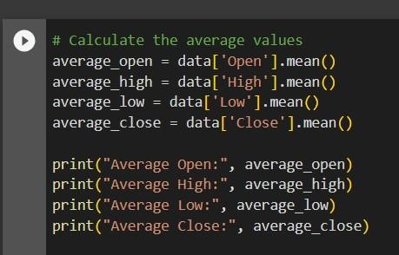

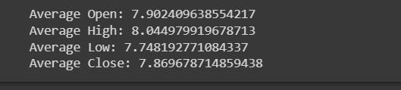

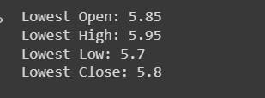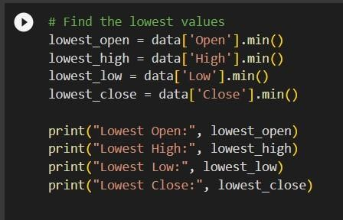

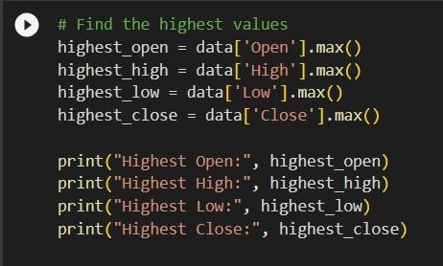

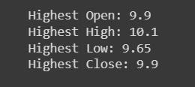

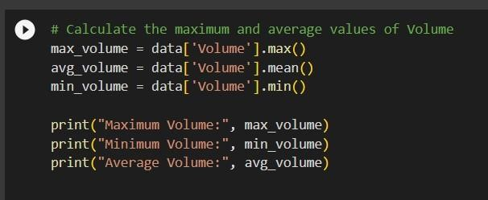

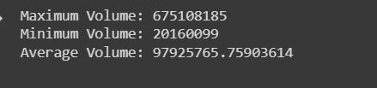

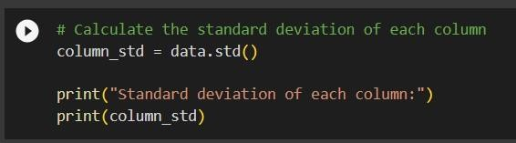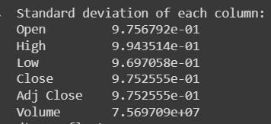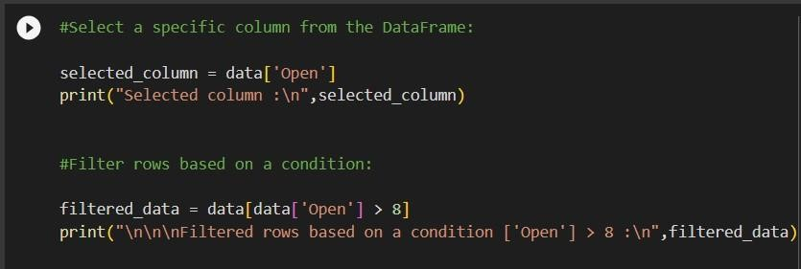

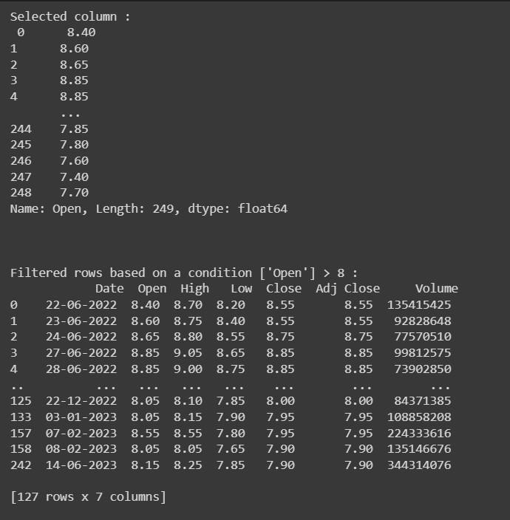

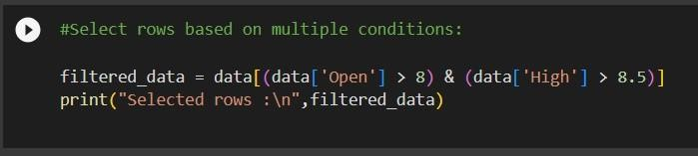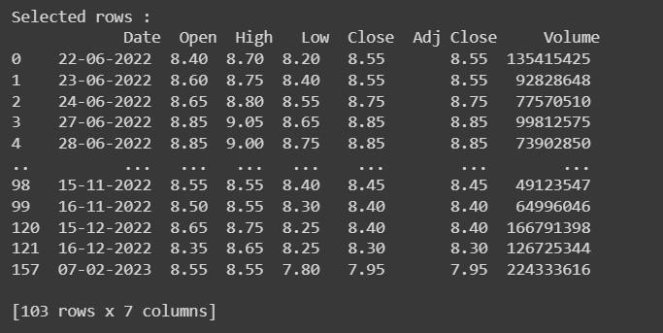



Data visualization is the process of representing data and information visually through charts, graphs, maps, and other graphical elements. It is a powerful technique that allows us to effectively communicate complex concepts, patterns, and trends in a visual format. Data visualization transforms complex data into visual representations that enhance understanding, reveal patterns, and support decision-making

